**Classroom Activity: Write a code for Array operators in the MongoDB collection.**

**Code: Array ($all) operator in MongoDB.**

FoodDelivery> db.vendors.find({ cuisines: { $all: ["Italian", "Mexican"] }});

**OUTPUT:**

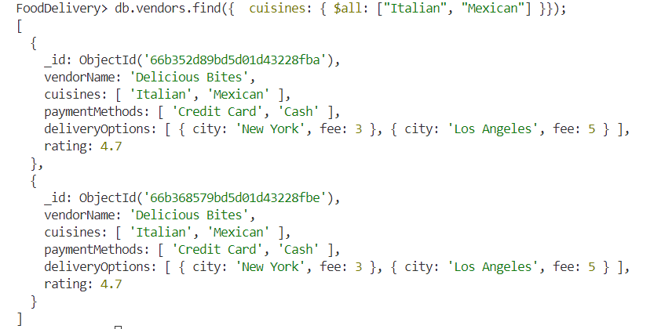

**Code: Array ($size) operator in MongoDB.**

FoodDelivery> db.vendors.find({ "paymentMethods": { $size: 3 }});

**OUTPUT:**

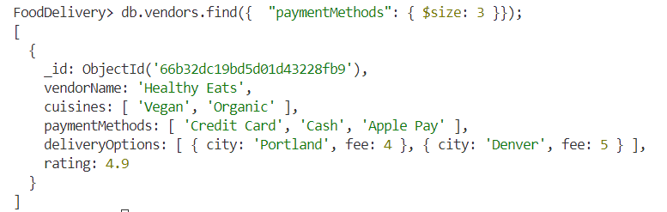

**Code: Array ($elemMatch) operator in MongoDB.**

FoodDelivery> db.vendors.find({ deliveryOptions: { $elemMatch: { city: "New York", fee: { $lte: 3 } } }});

**OUTPUT:**

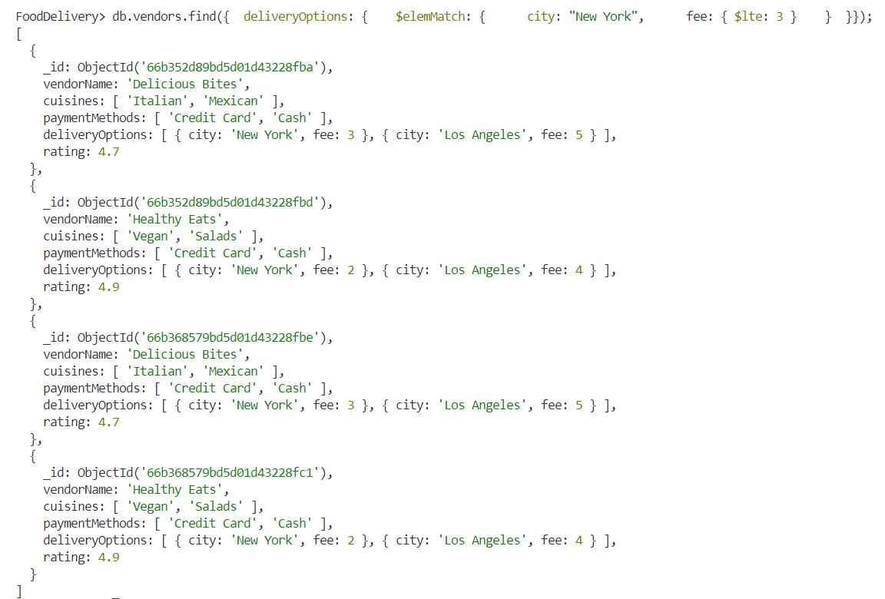

**Execution Steps:**

1. Install MongoDB compass and MongoDB shell
2. Create a new connection in MongoDB Compass
3. Create a new Database eg.)Food Delivery
4. Go to Visual Studio Code
5. Install the MongoDB for VS code extension
6. Click on the MongoDB icon on the navigation pane
7. Right click on the localhost:27017 connection
8. Select Launch MongoDB shell
9. Finally execute the above code.